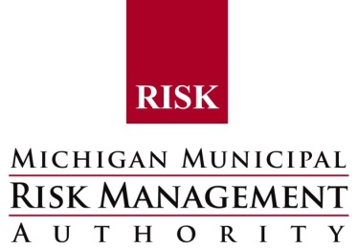

TRAINING OPPORTUNITY

Corrections Legal Update Training
For all levels of Jail Personnel

Session #1
October 3rd
9:00 a.m. – 1:30 p.m.

Bay College
2001 N. Lincoln Rd
Escanaba MI 49829

Session #2
October 17th
9:00 a.m. - 1:30 p.m.

Isabella Commission on Aging Building
2200 S. Lincoln Rd
Mt. Pleasant, MI

Session #3
October 20th
9:00 a.m. - 1:30 p.m.

Marshall Regional Law Enforcement Center
714 US HWY 27 N.
Marshall, MI 49068

Topics Presented: Correctional law update and current trends throughout Michigan. Presented by MMRMA Municipal Defense Attorneys.

Cost: There is no cost for this training. Non-Members welcome but may be limited to accommodate members. Lunch provided.

Registration: To register, please contact Randy Hazel at 313-480-5814 or rhazel@mmrma.org.

