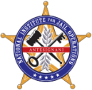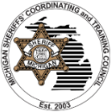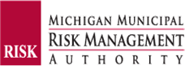

MICHIGAN SHERIFFS’ COORDINATING AND TRAINING COUNCIL, MICHIGAN MUNICIPAL RISK MANAGEMENT AUTHORITY
and the
NATIONAL INSTITUTE for JAIL OPERATIONS PRESENT the FALL 2023
MICHIGAN JAIL COMMAND STAFF ACADEMY
This Tuition Free* Command Staff level training is approved by the Michigan Sheriffs’ Coordinating and Training Council (MSCTC) and the Michigan Municipal Risk Management Authority (MMRMA). The program is designed and presented by the National Institute of Jail Operations (NIJO), to engage jail command staff that operate Local Correctional Facilities within Michigan. Upon completion, successful graduates will receive an Academy Completion Certificate from the MSCTC and the MMRMA, along with approximately 72 credit hours that may be applied toward the NIJO National Certified Correctional Supervisor (NCCS) or National Certified Correctional Executive (NCCE) certification. Attendance at all 3 Sessions of this course are required for successful Academy completion.

The 8- Core Management Areas of advanced training will consist of:

- Statistics and Data Driven Decision Making
- Leadership
- Report and Business Writing
- Proactive Liability Defense: Policy & Procedure, Audits & Inspections

- Budgets, Purchasing and RFP Management
- Personal Development
- Legal Issues
- Investigations and Preparing for Litigation

Course Schedule:
REGISTRATION DEADLINE:  SEPTEMBER 15, 2023 | Please see page 2 for Registration Form.  Attendance at all 3 sessions required.
Wednesday, Thursday, Friday October 11, 12, 13, 2023  8 a.m. till 5 p.m. | Session 1:  Attendee required 3-days of classroom instruction at Delta College in Midland, MI
Wednesday, Thursday, Friday October 25, 26, 27, 2023  8 a.m. till 5 p.m. | Session 2:  Attendee required 3-days of classroom instruction at  Delta College in Midland, MI
Wednesday, Thursday, Friday November 8, 9, 10, 2023  8 a.m. till 5 p.m. | Session 3 (Course Completion):  Attendee required 3-days of classroom instruction at Delta College in Midland, MI

Attendee Registration Requirements and Information:
  - Course is limited to first 24 participants. Limited to 2 attendees per Sheriff’s Office.
  - Limited to Jail Command Staff who operate a Local Correctional Facility in Michigan.
  - TUITION FREE* = When above registration requirements have been met, tuition is free for attendees. Lodging, breakfast, dinner, and travel expenses (including mileage) are the responsibility of the attendee or their Agency. (Lunch will be provided on training days to attendees.)
  - Location: Delta College in Midland, MI 48640.

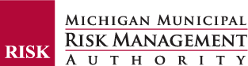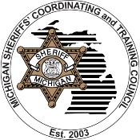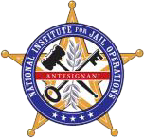
MICHIGAN JAIL COMMAND STAFF ACADEMY

FALL 2023 REGISTRATION FORM
Attendee Registration Requirements and Information:
  - Course is limited to first 24 participants. Limited to 2 attendees per Sheriff’s Office.
  - Limited to Jail Command Staff who operate a Local Correctional Facility in Michigan.
  - TUITION FREE* = When above registration requirements have been met, tuition is free for attendees. Lodging, breakfast, lunch, dinner, and travel expenses (including mileage) are the responsibility of the attendee or their Agency.
  - Location: Delta College Midland Campus- 419 East Ellsworth St., Midland, MI 48640

*Lodging suggestions will be included with your registration confirmation email.

Please print legibly OR type in responses:
ATTENDEE #1
FULL NAME: | LAST | FIRST | M.I.
DATE OF BIRTH: |  | PHONE/CELL #:
EMAIL: |  | LCOTS #:
AGENCY: |  | RANK:
SUPERVISOR: |  | FOOD ALLERGIES:
ATTENDEE #2
FULL NAME: | LAST | FIRST | M.I.
DATE OF BIRTH: |  | PHONE/CELL #:
EMAIL: |  | LCOTS #:
AGENCY: |  | RANK:
SUPERVISOR: |  | FOOD ALLERGIES:

REGISTRATION DEADLINE IS SEPTEMBER 15, 2023

EMAIL REGISTRATION FORM(S) TO THE MSCTC
training@msctc.org

REGISTRATION IS LIMITED TO 24, FIRST COME FIRST SERVE BASIS.

*LODGING INFORMATION: Lodging expenses are the responsibility of the attendee or their Agency. As a courtesy and convenience, optional lodging information will be included with your registration confirmation response.

