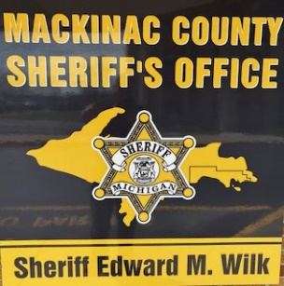 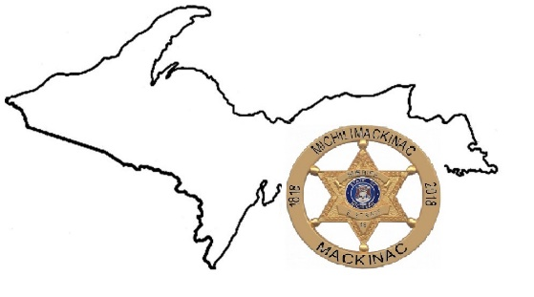 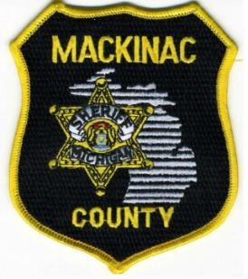

**Come live and work where others can only vacation for a few days!**

**MCOLES Licensed/Licensable preferred** (We maysponsor qualified academy prospects)

**Relaxed tattoo and beard policy**

**Popular year-round tourist destination** (including Mackinac Island & Les Cheneaux Islands)

**Regularly scheduled shifts**

**Every other weekend off**

**Mackinac County Residency preferred**

**Top pay at 2 years**

**External vest carriers**

**County provided BC/BS Health Care (Including dental/vision)**

**MERS Defined Contribution Retirement**

**Vacation, Sick and Personal Time earned at start of employment**

**Duties may include operating: Patrol Boats, ORV’s, Snowmobiles and Hovercraft**

***When:*** Applications are currently being accepted until May 25, 2025.

***Where:*** Mackinac County Sheriff’s Office 100 S. Marley, St. Ignace, MI 49781 – (906) 643-1911

***Positions:*** The Mackinac County Sheriff’s Office has full time openings for the position of Road Patrol Deputy. Applicants are expected to pass a drug screen, background investigation and oral interview.

***Pay and Benefits:*** Minimum starting pay from $25.05 – $32.52 an hour plus shift premium. No cost BC/BS health care for the employee and family. Yearly uniform allowance, longevity pay and vested retirement after 6 years. Total compensation package in excess of $82,000 yearly. All uniforms, training, patrol vehicle and equipment are paid for or provided by the employer.

**Application packets may be picked up at the Mackinac County Sheriff’s Office or downloaded and completed prior to your arrival:**

<https://www.mackinaccounty.net/departments/sheriffs-office/sheriffs-office-employment/>

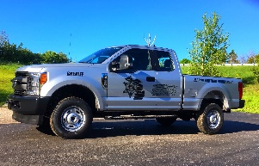  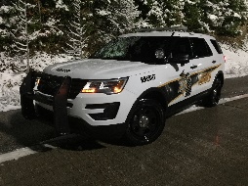 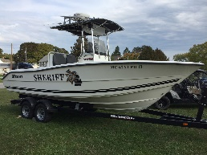 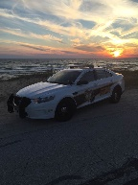 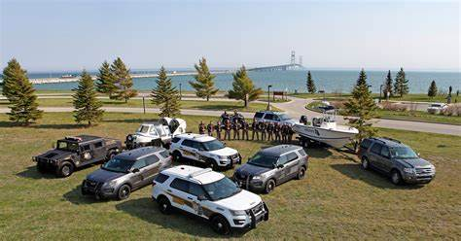

Mackinac County is an Equal Opportunity Provider and Employer

www.mackinaccounty.net/departments/sheriffs-office